Assignment 3
# Import libraries
import numpy as np
import pandas as pd
import matplotlib.pyplot as plt
import seaborn as sns

# 1️⃣ Initialize Random Seed (Replace 123 with your roll number)
roll_number = 123
np.random.seed(roll_number)

# 2️⃣ Generate Sales Data (12 months × 4 categories)
sales_data = np.random.randint(1000, 5001, size=(12, 4))

# 3️⃣ Convert to DataFrame
months = ["Jan", "Feb", "Mar", "Apr", "May", "Jun",
"Jul", "Aug", "Sep", "Oct", "Nov", "Dec"]

columns = ["Electronics", "Clothing", "Home & Kitchen", "Sports"]

df = pd.DataFrame(sales_data, columns=columns, index=months)

print("Sales Data:")
print(df)
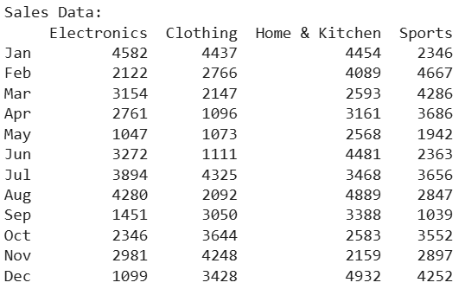
# 1️⃣ First 5 rows and summary statistics
print("\nFirst 5 rows:")
print(df.head())

print("\nSummary Statistics:")
print(df.describe())

# 2️⃣ Total sales per category and per month
print("\nTotal Sales Per Category:")
print(df.sum())

print("\nTotal Sales Per Month:")
print(df.sum(axis=1))

# 3️⃣ Average sales growth between consecutive months
growth = df.pct_change().mean() * 100
print("\nAverage Monthly Growth (%) per Category:")
print(growth)

# 4️⃣ Add Total Sales and Growth Rate columns
df["Total Sales"] = df.sum(axis=1)
df["Growth Rate"] = df["Total Sales"].pct_change() * 100

print("\nUpdated DataFrame:")
print(df)

# 5️⃣ Apply Discount
if roll_number % 2 == 0:
df["Electronics"] = df["Electronics"] * 0.90
print("\n10% discount applied to Electronics")
else:
df["Clothing"] = df["Clothing"] * 0.85
print("\n15% discount applied to Clothing")

print("\nData After Discount:")
print(df)
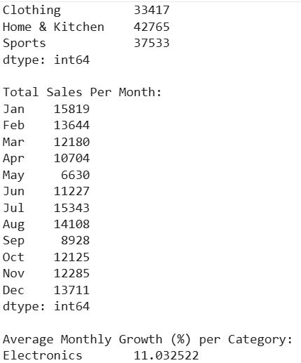
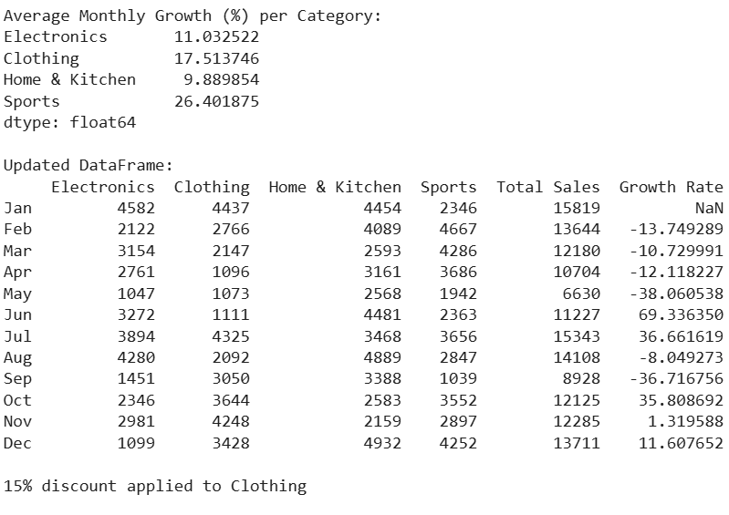
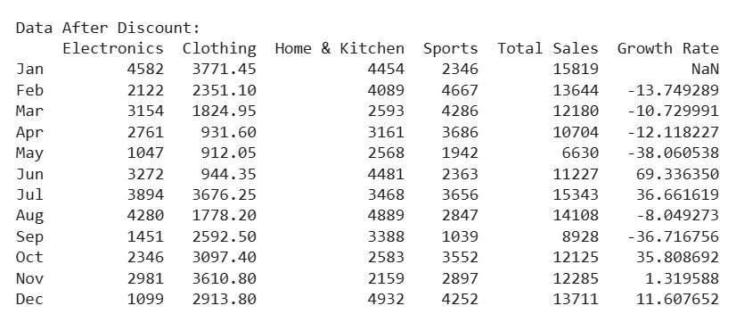
# 1️⃣ Line Plot for Monthly Sales Trends
plt.figure()
for col in columns:
plt.plot(df.index, df[col])

plt.title("Monthly Sales Trends")
plt.xlabel("Month")
plt.ylabel("Sales")
plt.legend(columns)
plt.xticks(rotation=45)
plt.show()

# 2️⃣ Box Plot for Sales Distribution
plt.figure()
sns.boxplot(data=df[columns])
plt.title("Sales Distribution by Category")
plt.show()
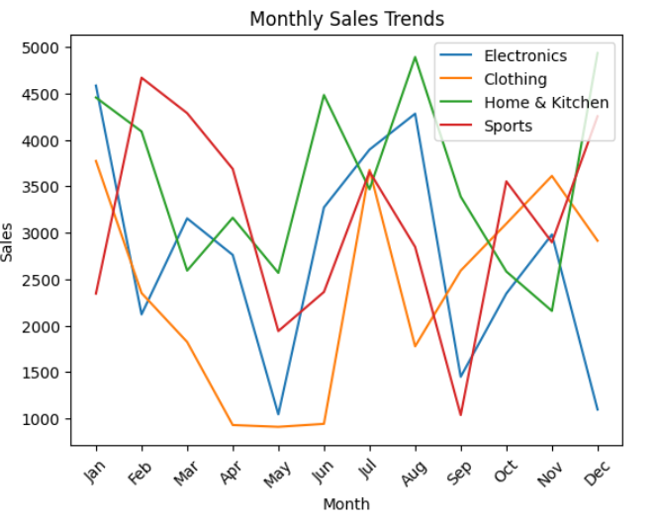
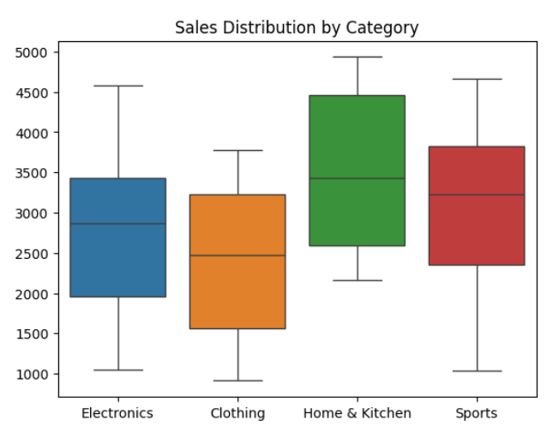
array = np.array([[1, -2, 3], [-4, 5, -6]])

# i️⃣ Element-wise absolute value
print("Absolute Value:\n", np.abs(array))

# ii️⃣ Percentiles
print("\nFlattened Percentiles (25,50,75):")
print(np.percentile(array.flatten(), [25, 50, 75]))

print("\nColumn-wise Percentiles:")
print(np.percentile(array, [25, 50, 75], axis=0))

print("\nRow-wise Percentiles:")
print(np.percentile(array, [25, 50, 75], axis=1))

# iii️⃣ Mean, Median, Std
print("\nFlattened Mean:", np.mean(array))
print("Flattened Median:", np.median(array))
print("Flattened Std:", np.std(array))

print("\nColumn-wise Mean:", np.mean(array, axis=0))
print("Row-wise Mean:", np.mean(array, axis=1))
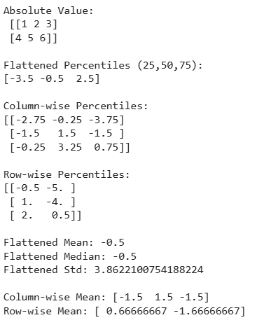
a = np.array([-1.8, -1.6, -0.5, 0.5, 1.6, 1.8, 3.0])

print("Floor:", np.floor(a))
print("Ceiling:", np.ceil(a))
print("Truncated:", np.trunc(a))
print("Rounded:", np.round(a))
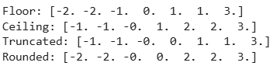
lst = [10, 20, 30, 40]

pos1 = 1
pos2 = 3

print("Before Swap:", lst)

temp = lst[pos1]
lst[pos1] = lst[pos2]
lst[pos2] = temp

print("After Swap:", lst)
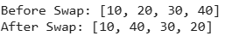
s = {1, 2, 3, 4}

print("Original Set:", s)

# Convert to list
lst = list(s)

pos1 = 0
pos2 = 2

# Swap
lst[pos1], lst[pos2] = lst[pos2], lst[pos1]

# Convert back to set
s = set(lst)

print("Updated Set:", s)
